# **ECEN 215 – PRIN OF ELECTRICAL ENGR**

# **Spring 2019**

## **Lab 3: Introduction to Op Amps**



**Submitted by:**

|  |  |  |
| --- | --- | --- |
| **Student Name** | **UIN:** | **Section #** |
| Daniel Lopez | 426001591 | 516 |
| Adam Johnston | 516007336 |
| Jared Blunt | 524009660 |  |

**Date Performed: April 8th, 2019**

1. **Objective**

This lab is as an introduction to Operational Amplifiers (Op Amps) and shows how Op Amps can amplify an incoming voltage. Crucially, it also shows how Op Amps are able, not only to amplify signals; it presents their ability to invert the source input signal from positive to negative or vice versa. This lab truly showcases the importance of the fact that an Op Amp does not simply have an effect on Alternating Current Circuits, but it allows students to see how it affects this kind of circuit.

1. **Procedure**

**Circuit 3.2a:**

1. Build the circuit depicted in figure 3.2a (note: use two 10kΩ in // to achieve 5kΩ resistance)
2. Measure and record the resistance of the components values using a multimeter
3. Connect the circuit to the Analog Discovery
   1. Set the input voltage to be .5 Volts (DC)
   2. Ensuring that +15V and -15V are in the correct inputs
4. Use the Analog Discovery to measure in the input and output voltages

**Circuit 3.2b:**

1. Build the circuit depicted in figure 3.2b (note: use two 10kΩ in // to achieve 5kΩ resistance)
2. Measure and record the resistance of the components values using a multimeter
3. Connect the circuit to the Analog Discovery
   1. Set the input voltage to be .5 Volts (AC)
   2. Using +15V and -15V (DC) and ensure they are in the correct inputs
4. Screenshot the input and output WaveForms of the circuit to analyze and compare with the results from circuit 3.2a
5. **Difficulties**
6. Damaged components
7. Components with different values than what was needed for the lab
8. Being unable to measure individuals inductors
9. Difficulty keeping wires inside the Analog Discovery
10. Loose wires causing the breadboard to
11. Issues with the WaveForms software giving incorrect data
12. Interpolating data from the WaveForms software
13. **Results**

D / C

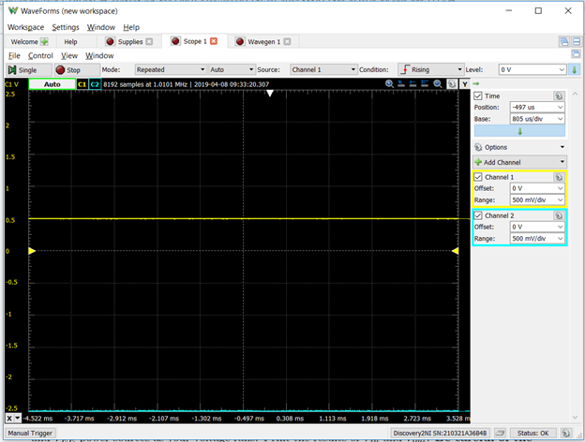

A / C

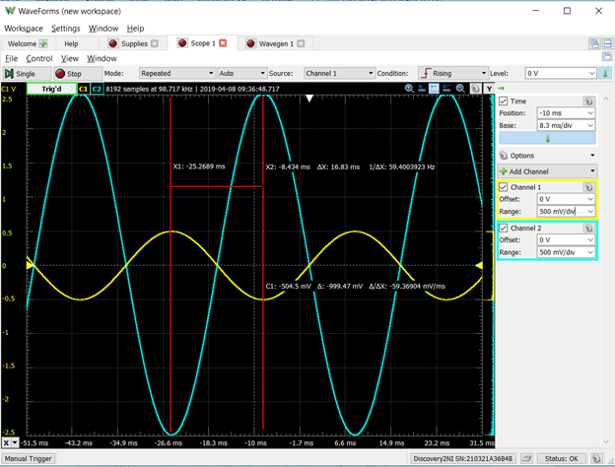

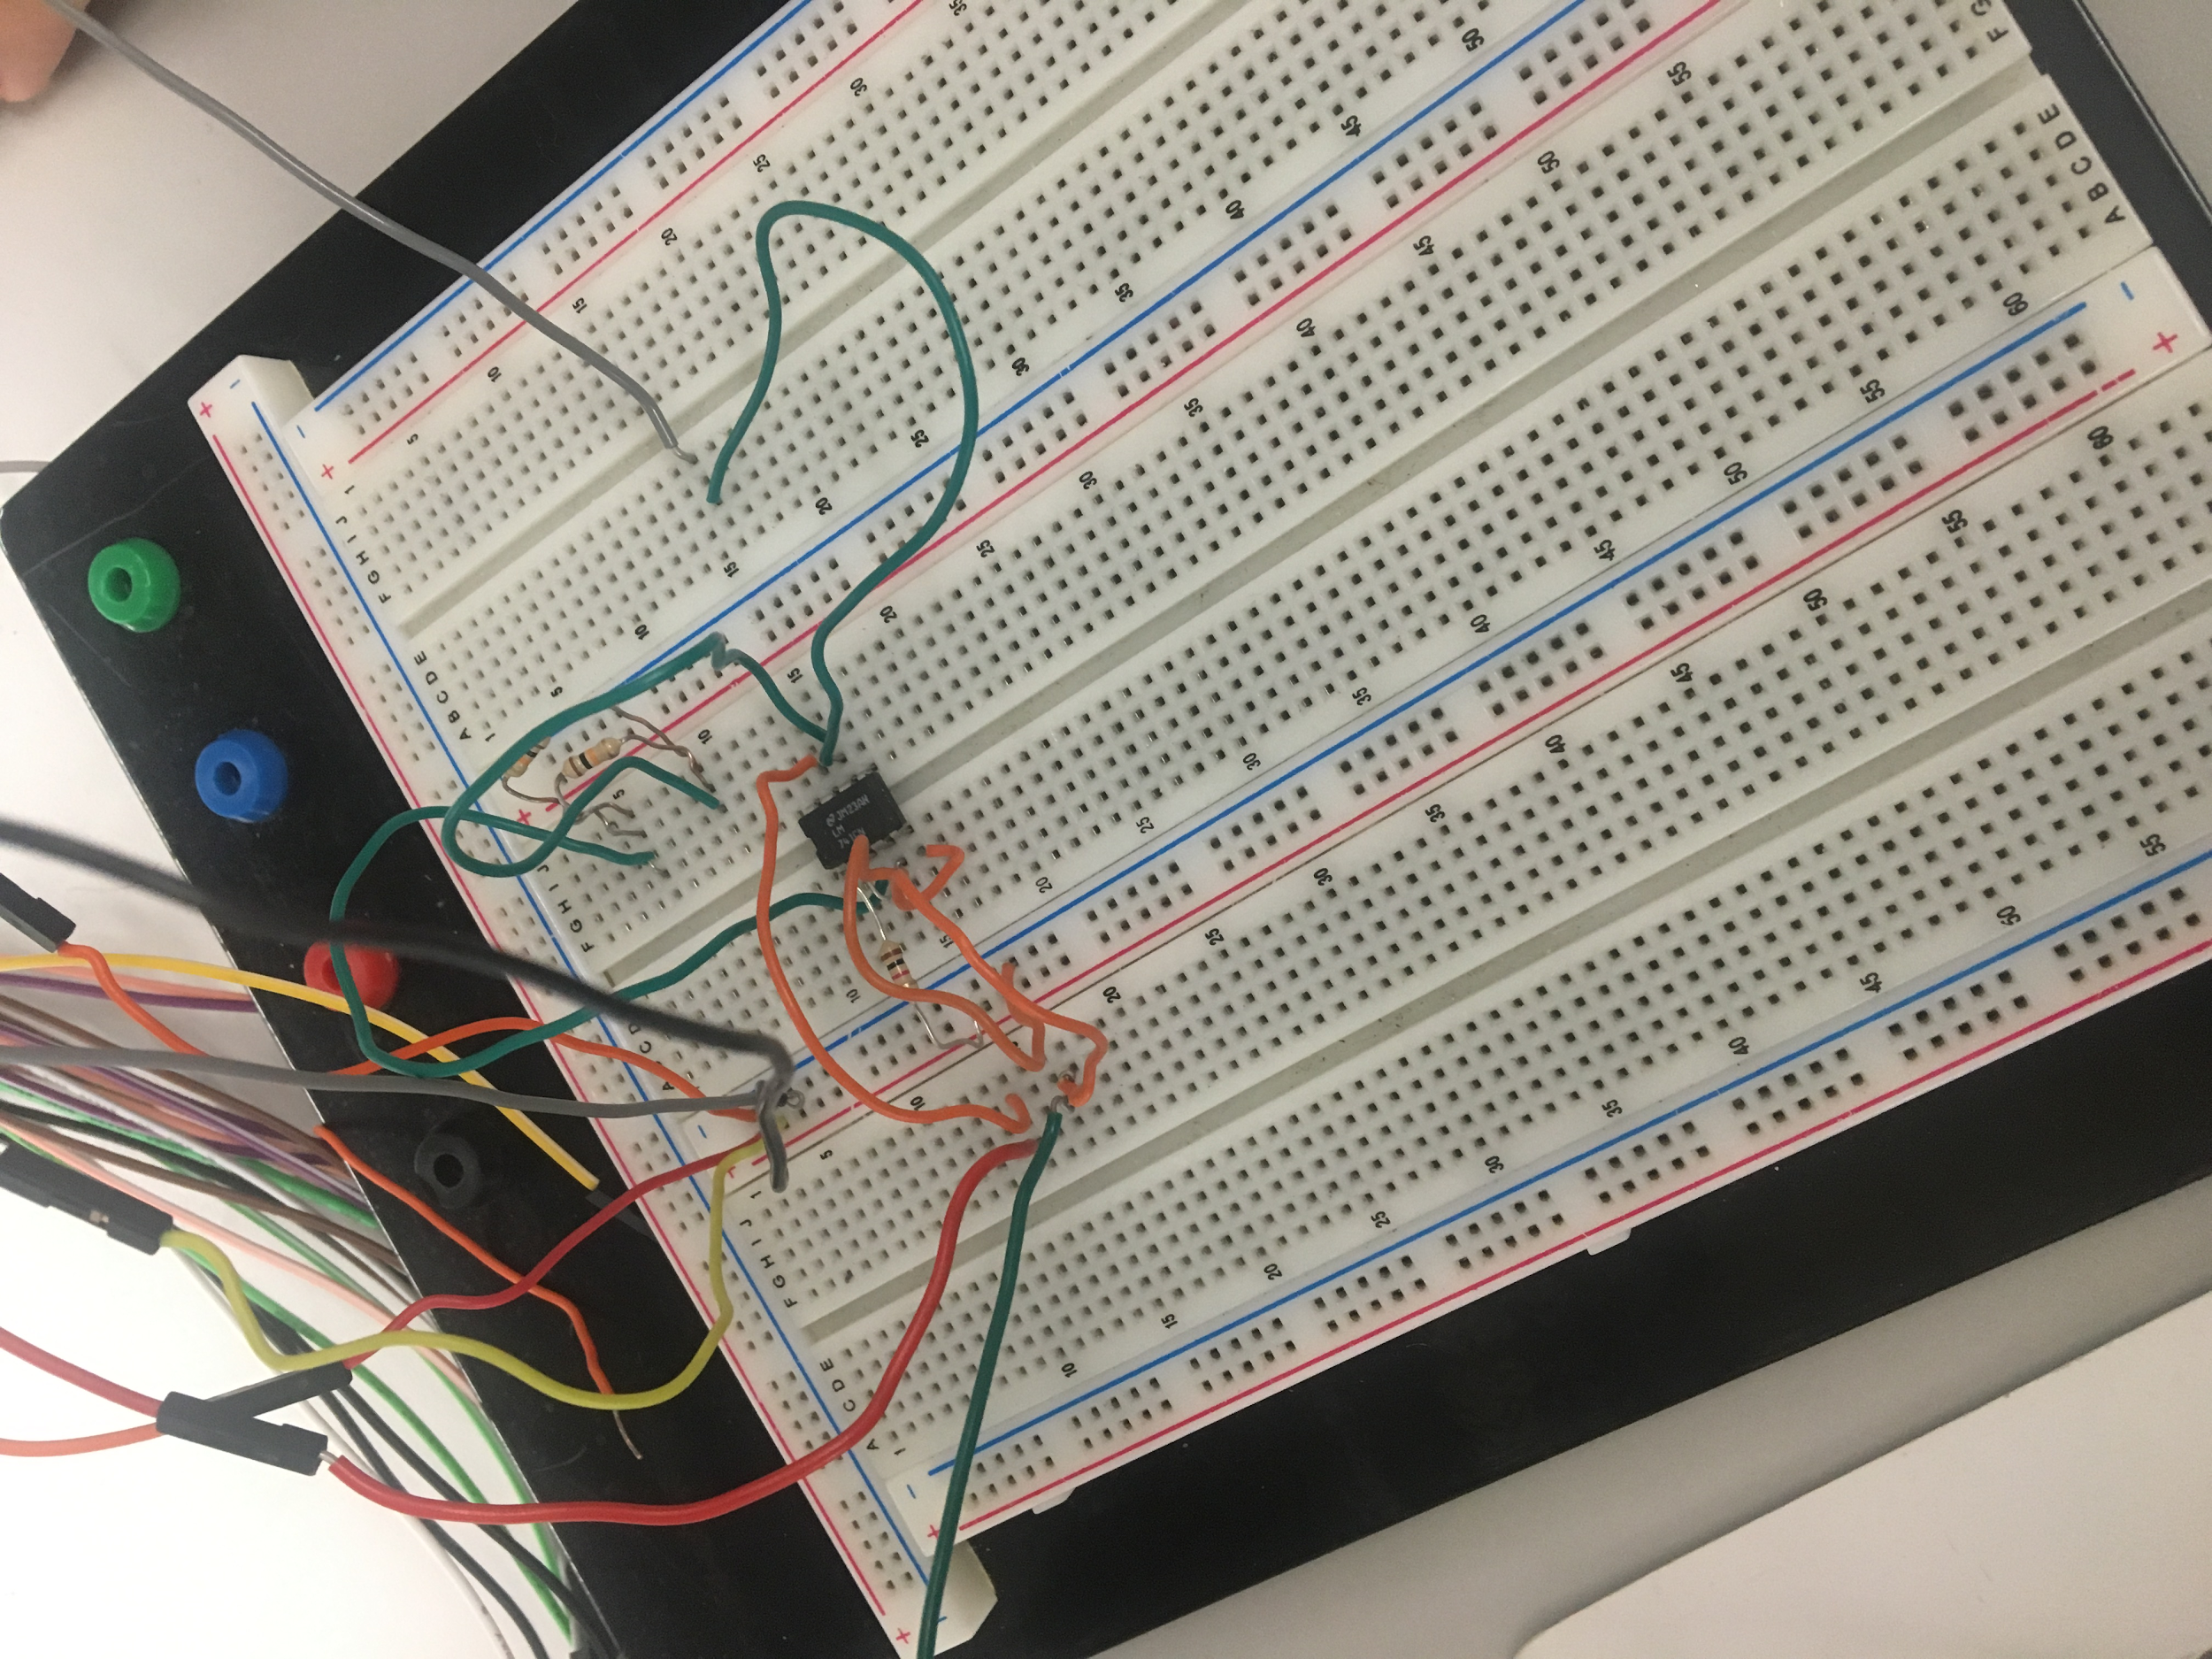

**Initial Conditions**

|  |  |
| --- | --- |
| **R1** | 983 kΩ |
| **R2** | 4.943 kΩ |
| **f** | 30 Hz |
| **ΔT** | 0.01683 s |
| **ΔΦ** | 181.76° |

1. **Conclusion**

In conclusion, our experiment was a success. We were able to fully simulate and

understand Op amps and how they work in a circuit. This experiment helped us to grab

a better understanding that cemented what knowledge we had acquired from class.

Although this lab was a success there was still room for error. For example, we could

have made an error in our calculations. Also, some of the equipment could have been

malfunctioned giving us errors from the very beginning.